Modera to deliver a new digital solution for Nissan

**Automotive software company Modera was selected to provide automotive manufacturer Nissan with a digital solution to help introduce a new business model.**

Stockholm, 28.11.2023. Automotive software company Modera was chosen to deliver an innovative digital solution for Nissan Nordic Europe, to support the car manufacturer with the introduction of a new business model in Sweden, known as the agency model. The new approach aims to adapt to the ever-changing customer buying behavior, restructure the dealer network, and maintain customer experience as the focal point of the business.

Under the new model, Nissan will take responsibility for customer purchases and ownership, manage vehicle inventory in the market, establish a consistent pricing strategy across all channels, and secure direct sales with customers. The distribution network will act as agents, providing a key point of contact for customers looking for information or to book a test drive. They will also manage car deliveries on behalf of Nissan and offer aftermarket services to customers.

“While we had several suppliers to choose from, we decided to go with Modera due to their modern product that is purpose built for automotive retail and an agile team with start-up mindset to support delivery,” explained Cecilie Pedersen, Country Manager, Nissan Sweden.

Modera’s new solution will be integrated with Nissan’s online and backend systems, as well as financing and insurance and other third-party tools to deliver a comprehensive multichannel retail experience for Nissan customers.

“For Modera, this is a huge step towards becoming an automotive software provider to be reckoned with by all OEMs. We are extremely grateful to Nissan for choosing Modera to be their partner on this journey. We are eager to expand this cooperation into other regions, whether by providing software to support potential agency model or the traditional dealership model,” said Siim Vips, Chairperson of the Supervisory Board at Modera.

About Nissan

Nissan is a global car manufacturer with its headquarters in Yokohama, Japan. Nissan Nordic Europe is a regional business responsible for Nissan sales and aftersales representative for Denmark, Finland, Norway, Sweden, Estonia, Latvia and Lithuania. With 175 employees representing 24 different nationalities and well over 200 dealership partners, Nissan provides automotive products and services to private and corporate customers throughout Scandinavia and Baltic countries. Learn more here www.nissan-europe.com / [www.nissan.se](http://www.nissan.se/)

About Modera

Modera is a software company providing ​​next-generation customer experience solutions for the automotive industry. For the past 16 years, Modera has offered a vast selection of digital sales tools to car retailers, distributors, and OEMs. Their product range includes e-commerce, sales and CRM tools, a digital showroom, and solutions to support both traditional vehicle distribution as well as the agency sales model. Modera has delivered more than 1500 projects in 14 countries and currently works with more than 30 brands. They are a NASDAQ First North listed company. Learn more at [www.modera.com](http://www.modera.com/).

___________________________________________________________  
Images to be attached, descriptions on next pages

Attached image 20230626_173727.jpg

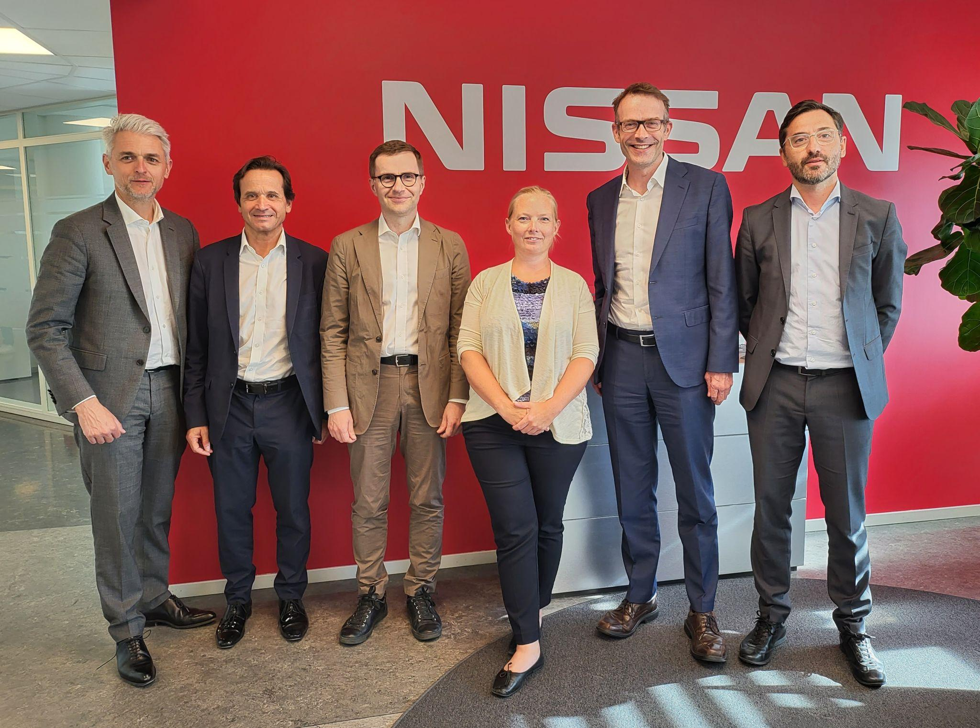

Jean-Philippe Roux (Vice President, Distribution, AMIEO, Nissan), Jordi Vila (Division Vice President Marketing & Sales, Nissan), Siim Vips (Chairperson, Modera), Cecilie Therese Pedersen (Country Director, Sweden, Nissan), Leon Dorssers (Senior Vice President S&M AMIEO Region, Nissan), Christian Costaganna (Managing Director, Nissan Nordic Europe)

Attached image: 20230626_173741.jpg

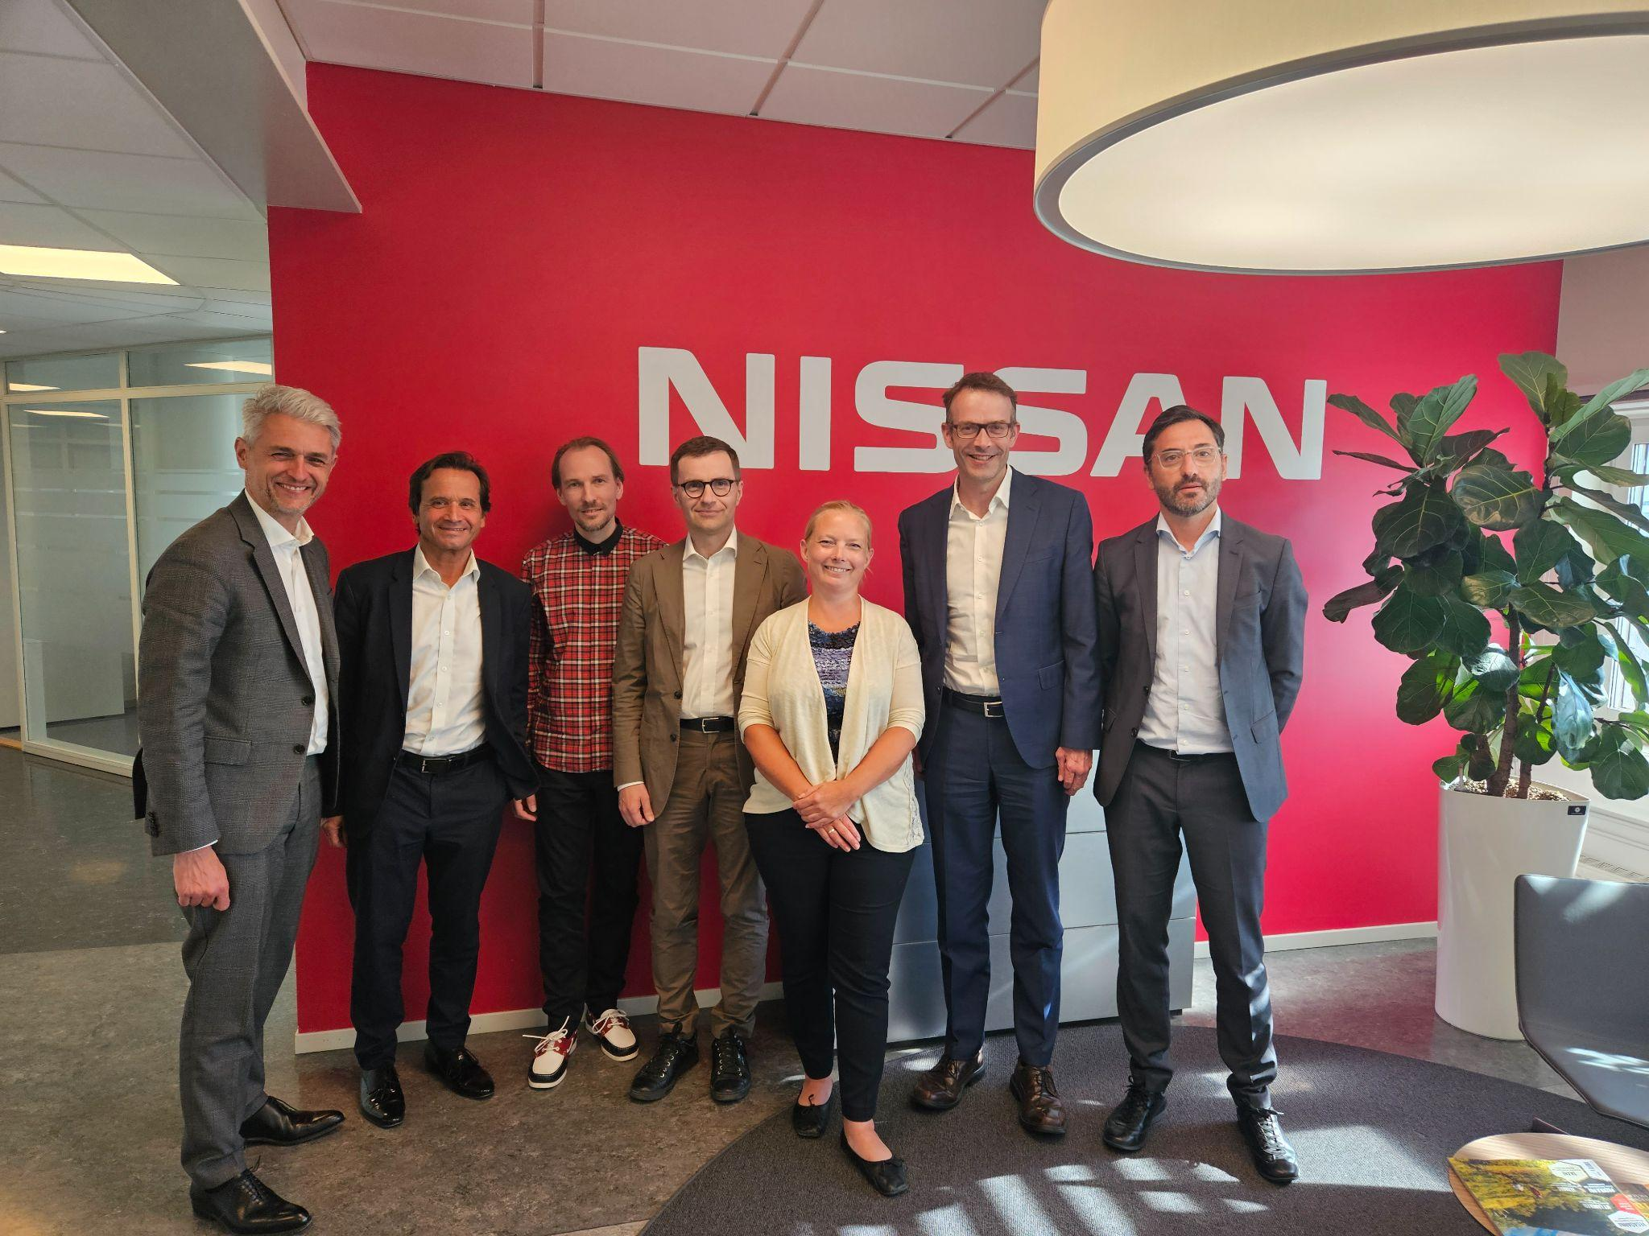

Jean-Philippe Roux (Vice President, Distribution, AMIEO, Nissan), Jordi Vila (Division Vice President Marketing & Sales, Nissan), Kristjan Vaga (VP Product, Modera), Siim Vips (Chairperson, Modera), Cecilie Therese Pedersen (Country Director, Sweden, Nissan), Leon Dorssers (Senior Vice President S&M AMIEO Region, Nissan), Christian Costaganna (Managing Director, Nissan Nordic Europe).